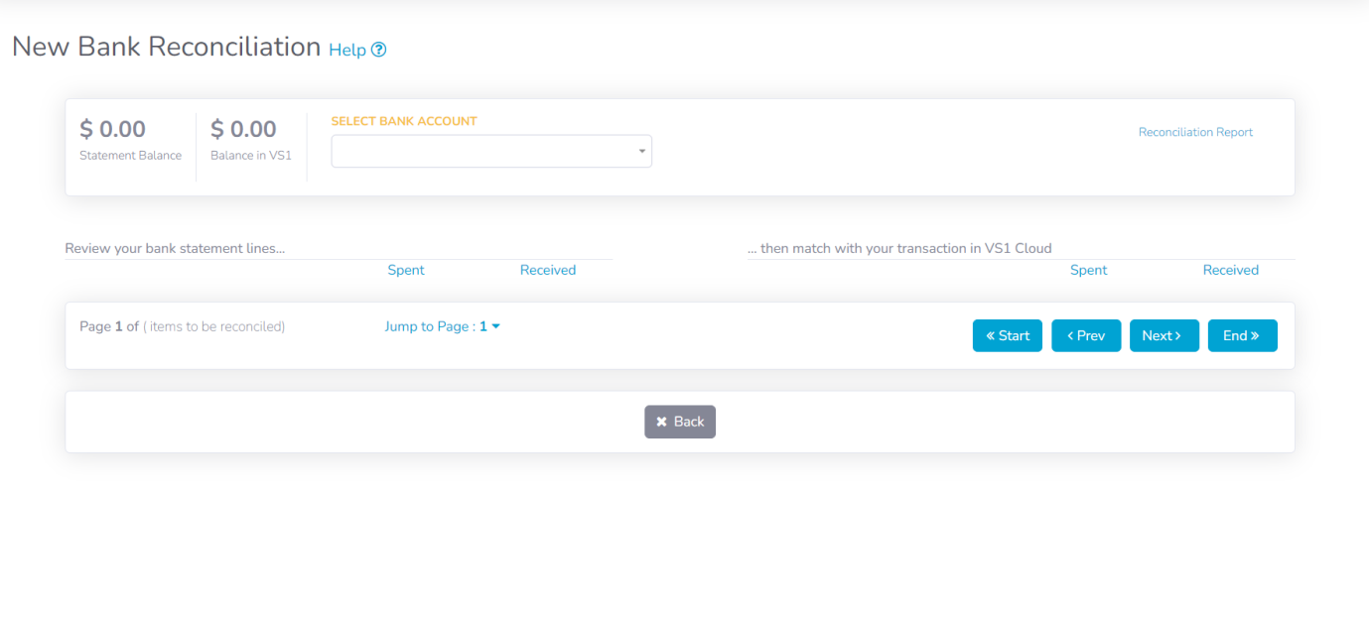

Default Bank should load and stored last save Bank account when opening an new recon

VS1 Screenshot

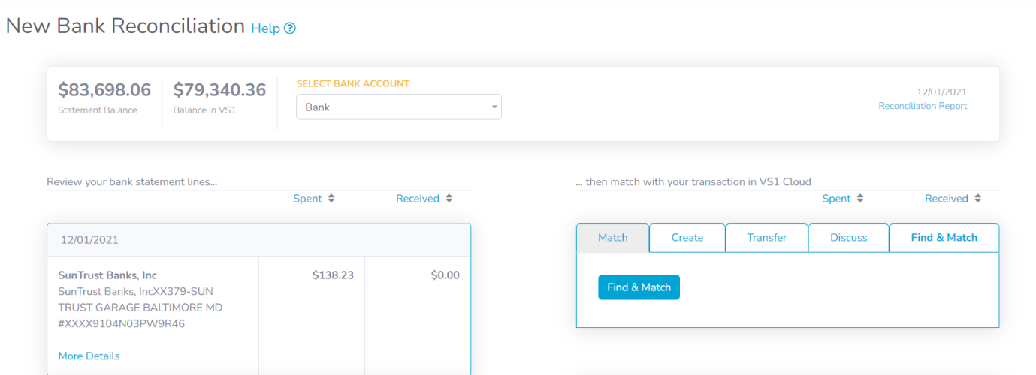

Remove “Find & Match” button to be removed. (Because there is already a Find & Match section)

Match column should only come up when there is something to Match

VS1 Screenshot

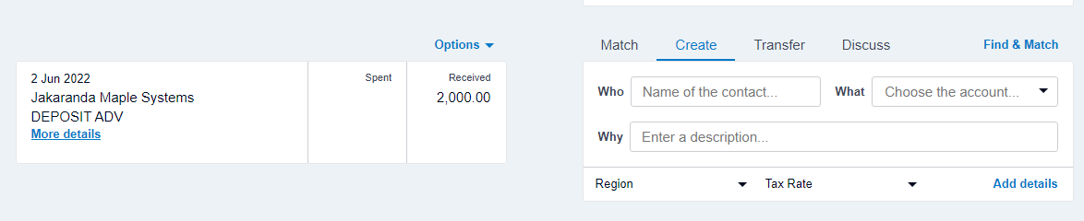

Name should pull to Who automatically (Or at least find the name when searching for it, if doesn’t exist create the contact)

Xero Screenshots

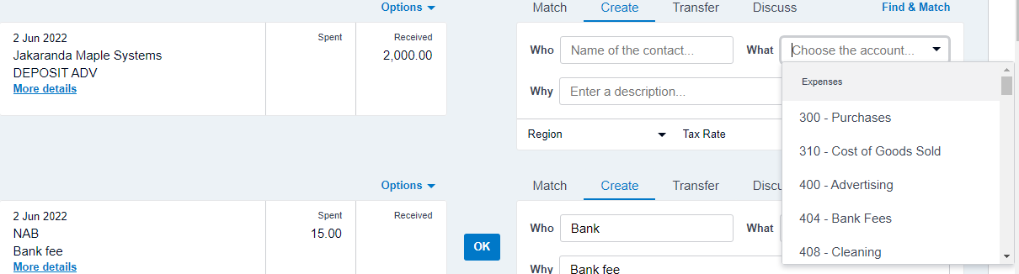

“What” needs to pull chart of accounts list

Xero Screenshots

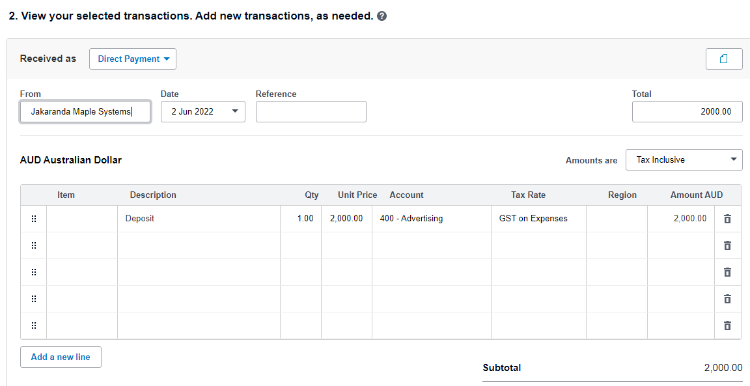

Once you have clicked “more details” it should load with all this information already filled in (You just need to select an Item manually)

Xero Screenshots

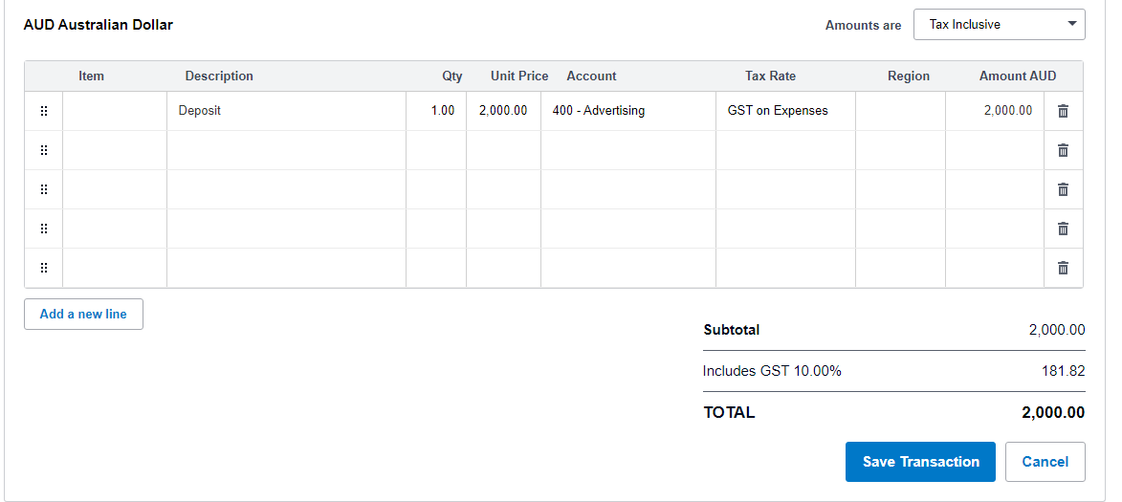

Click Save Transaction to Save or Cancel to cancel (Please add these buttons)

Xero Screenshots

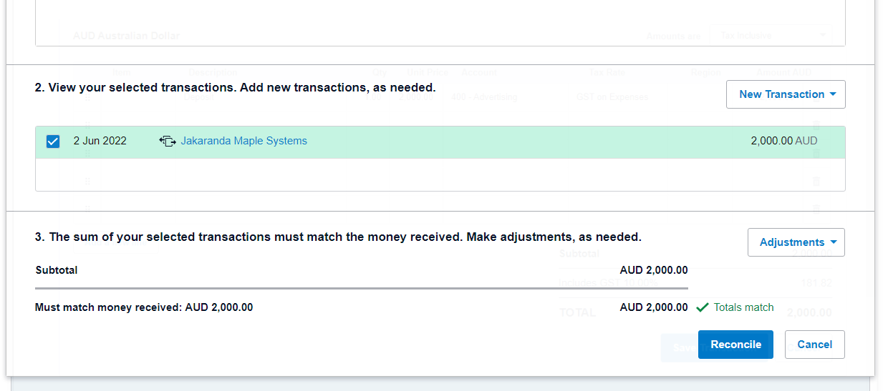

Transaction gets loaded. Click Reconcile to reconcile this specific transaction. Scroll up and continue to match against the bank statement as per the first screenshot of this document

NB You need to make our Bank Reconciliation the same way it works in Xero. Currently it is not.

Xero Screenshots